2.1.1. History of Embedded System

The origins of the microprocessor and the microcontroller can be traced back to the MOS integrated circuit, which is an integrated circuit chip fabricated from the MOSFETs (metal-oxide-semiconductor field-effect transistors) and was developed in the early 1960s. By 1964, MOS chips had reached higher transistor density and lower manufacturing costs than bipolar chips. MOS chips further increased in complexity at a rate predicted by Moore's law, leading to large-scale integration (LSI) with hundreds of transistors on a single MOS chip by the late 1960s. The application of MOS LSI chips to computing was the basis for the first microprocessors, as engineers began recognizing that a complete computer processor system could be contained on several MOS LSI chips.

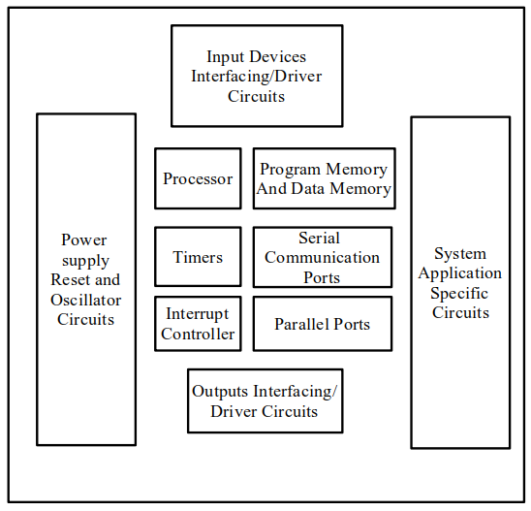The first multi-chip microprocessors, the Four-Phase Systems AL1 in 1969 and the Garrett Ai Research MP944 in 1970, were developed with multiple MOS LSI chips. The first single-chip microprocessor was the Intel 4004, released on a single MOS LSI chip in 1971. It was developed by Federico Faggin, using his silicon-gate MOS technology, along with Intel engineers Marcian Hoff and Stan Mazor, and Busicom engineer Masatoshi Shima.

Figure 2.1 Component of the embedded system hardware

**2.2. Microcontroller**

A microcontroller can be considered a self-contained system with a processor, memory and peripherals and can be used as an embedded system. The majority of microcontrollers in use today are embedded in other machinery, such as automobiles, telephones, appliances, and peripherals for computer system.

A microcontroller is a computer. All computers whether we are talking about a personal desktop computer or a large mainframe computer or a microcontroller have several things in common:

* A microcontroller is often small and low cost. The components are chosen to minimize size and to be as inexpensive as possible.
* Microcontrollers do one thing well. There are a number of other common characteristics that define microcontrollers. If a computer matches a majority of these characteristics, then you can call it a "microcontroller".
* Microcontrollers are "embedded" inside some other device (often a consumer product) so that they can control the features or actions of the product. Another name for a microcontroller, therefore, is "embedded controller".
* The CPU loads the program from somewhere. On your desktop machine, the browser program is loaded from the hard disk.
* A microcontroller is often, but not always, ruggedized in some way. The microcontroller controlling car's engine, for example, has to work in temperature extremes that a normal computer generally cannot handle. A car's microcontroller in Alaska has to work find in -30-degree F (-34C) weather, while the same microcontroller in Nevada might be operating at 120-degree F (49C). When you add the heat naturally generated by the engine, the temperature can go as high as 150- or 180-degrees F (65-80C) in the engine compartment. On the other hand, a microcontroller embedded inside a VCR hasn't been ruggedized at all.
* And the computer has some input and output devices so it can talk to people. A hard disk is an 1/0 device it handles both input and output.
* The desktop computer you are using is a "general purpose computer" that can run any of thousands of programs. Microcontrollers are "special purpose computers".
* The computer has some RAM where it can store "variables".
* A microcontroller has a dedicated input device and often has a small LED or LCD display for output. A microcontroller also takes input from the device it is controlling and controls the device by sending signals to different components in the device. For example, the microcontroller inside a TV takes input from the remote control and displays output on the TV screen. The controller controls the channel selector, the speaker system and certain adjustments on the picture tube electronics such as tint and brightness. The engine controller in a car takes input from sensors such as the oxygen and knock sensors and controls things like fuel mix and spark plug timing. A microwave oven controller takes input from a keypad, displays output on an LCD display and controls a relay that Q 4 turns the microwave generator on and off.
* A microcontroller has a dedicated input device and often has a small LED or LCD display for output. A microcontroller also takes input from the device it is controlling and controls the device by sending signals to different components in the device. For example, the microcontroller inside a TV takes input from the remote control and displays output on the TV screen. The controller controls the channel selector, the speaker system and certain adjustments on the picture tube electronics such as tint and brightness. The engine controller in a car takes input from sensors such as the oxygen and knock sensors and controls things like fuel mix and spark plug timing. A microwave oven controller takes input from a keypad, displays output on an LCD display and controls a relay that Q 4 turns the microwave generator on and off.
* In many products, such as microwave ovens, the demand on the CPU is fairly low and price is an important consideration. In these cases, manufacturers turn to dedicated microcontroller chips- chips that were originally designed to be low-cost, small, low-power embedded CPUs [7].
* Although there are several microcontrollers, these microcontrollers are more complex, expensive and difficult. Arduino is easy to implement for beginners. In its simplest form, an Arduino is a tiny computer that you can program to process inputs and outputs going to and from the chips. The Arduino is what is known as a physical or Embedded Computing platform, which means that it is an interactive system that through the use of hardware and software can interact with its environment. Therefore, we use Arduino microcontroller.

**2.3. Arduino**

Arduino is an open-source electronics platform based on easy-to-use hardware and software. Arduino boards are able to read inputs - light on a sensor, a finger on a button, or a Twitter message - and turn it into an output - activating a motor, turning on an LED, publishing something online. You can tell your board what to do by sending a set of instructions to the microcontroller on the board. To do so you use the Arduino Programming Language (based on Wiring), and the Arduino Software (IDE), based on Processing.

Over the years Arduino has been the brain of thousands of projects, from everyday objects to complex scientific instruments. A worldwide community of makers - students, hobbyists, artists, programmers, and professionals - has gathered around this open-source platform, their contributions have added up to an incredible amount of accessible knowledge that can be of great help to novices and experts alike.

Arduino was born at the Ivrea Interaction Design Institute as an easy tool for fast prototyping, aimed at students without a background in electronics and programming. As soon as it reached a wider community, the Arduino board started changing to adapt to new needs and challenges, differentiating its offer from simple 8-bit boards to products for IoT applications, wearable, 3D printing, and embedded environments. All Arduino boards are completely open-source, empowering users to build them independently and eventually adapt them to their particular needs. The software, too, is open-source, and it is growing through the contributions of users worldwide.

Arduino offers some advantages for teachers, students, and interested amateur over other systems:

* Inexpensive
* Cross-platform
* Simple, clear programming environments
* Open source and extensible
* Open source and extensible

2.3.1. Arduino Software

* It is easily available for operating systems like MAC, Windows, Linux and runs on the Java Platform that comes with inbuilt functions and commands that play a vital role for debugging, editing and compiling the code in the environment.
* A range of Arduino modules available including Arduino Uno, Arduino Mega, Arduino Leonardo, Arduino Micro and many more.
* Each of them contains a microcontroller on the board that is actually programmed and accepts the information in the form of code.
* The main code, also known as a sketch, created on the IDE platform will ultimately generate a Hex File which is then transferred and uploaded in the controller on the board.
* The IDE environment mainly contains two basic parts: Editor and Compiler where former is used for writing the required code and later is used for compiling and uploading the code into the given Arduino Module.
* This environment supports both C and C++ languages.

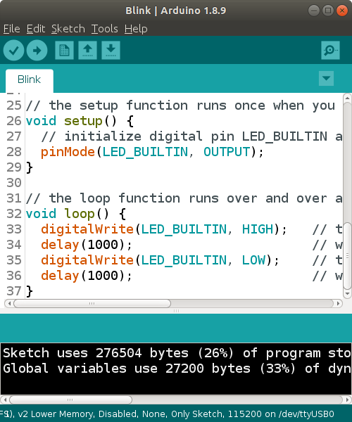

Figure 2.2 Arduino IDE

**2.4. Applications Area**

Embedded systems are commonly found in consumer, cooking, automotive, medical and military applications.

Telecommunication systems employ numerous embedded systems from telephone switches for the network to cell devices for sensing and controlling.

Transportation systems from flight to automobiles increasing use embedded systems. New airplanes contain advanced avionics such as inertial guidance systems and GPS receivers that also have considerable safety requirements. Various electronic motors – brushless DC motors, induction motors and DC motors -use vehicles increasingly use embedded systems to maximize efficiency and reduce pollution. Other automotive safety systems include antilock braking system (ABS), Electronic Stability Control (ESC/ESP), traction control (TCS) and automatic four-wheel drive.

Medical equipment uses embedded systems for vital signs monitoring, electronic stethoscopes for amplifying sounds.

A new class of miniature wireless devices called motes is networked wireless sensors. Wireless sensor networking, WSN, makes use of miniaturization made possible by advanced IC design to couple full wireless subsystems to sophisticated sensors, enabling people and companies to measure a myriad of things in the physical world and act on this information through IT monitoring and control systems. These motes are completely self-contained, and will typically run off a battery source for years before the batteries need to be changed or charged.

Embedded Wi-Fi modules provide a simple means of wirelessly enabling any device which communicates via a serial port.

According to their background theories, the embedded systems are electronic systems that contain a microcontroller. Microcontrollers are particularly suited for used in embedded systems for real-time control application with on-clip programed memory and devices. There are many others microcontroller and microcontroller-platforms available for physical computing. Among them, Arduino an open-source electronic platform based on easy-to-use hardware and software. Therefore, the proposed system which is based on Arduino hardware and Arduino IDE is system design.

**2.5. Web Development**

Web development is the work involved in developing a web site for the Internet or an intranet. Web development can range from developing a simple single static page of plain text to complex web-based internet applications, electronic businesses, and social network services.A more comprehensive list of tasks to which web development commonly refers, may include web engineering, web design, web content development, client liaison, client-side/server-side scripting, web server and network security configuration, and e-commerce development.

Among web professionals, "web development" usually refers to the main non-design aspects of building web sites: writing markup and coding. Web development may use content management systems (CMS) to make content changes easier and available with basic technical skills.

For larger organizations and businesses, web development teams can consist of hundreds of people (web developers) and follow standard methods like Agile methodologies while developing websites. Smaller organizations may only require a single permanent or contracting developer, or secondary assignment to related job positions such as a graphic designers or information systems technician.

Web development may be a collaborative effort between departments rather than the domain of a designated department. There are three kinds of web developer specialization: front-end developer, back-end developer, and full-stack developer. Front-end developers responsible for behavior and visuals that run in the user browser, while back-end developers deal with the servers. Every Web Developer must have a basic understanding of HTML, CSS, and JavaScript.

Responsive Web Design is used in all types of modern web development. ECMAScript 5 (JavaScript 5) is supported in all modern browsers. Take a good look at it, especially the new array functions.

* **HTML** is the markup language that we use to structure and give meaning to our web content, for example defining paragraphs, headings, and data tables, or embedding images and videos in the page.
* **CSS** is a language of style rules that we use to apply styling to our HTML content, for example setting background colors and fonts, and laying out our content in multiple columns.
* **JavaScript** is a scripting language that enables you to create dynamically updating content, control multimedia, animate images, and pretty much everything else.

2.5.1. PHP

PHP (recursive acronym for PHP: Hypertext Preprocessor) is a widely-used open-source general-purpose scripting language.

That is especially suited for web development and can be embedded into HTML. Instead of lots of commands to output HTML (as seen in C or Perl), PHP pages contain HTML with embedded code that does "something" (in this case, output "Hi, I'm a PHP script!").

The PHP code is enclosed in special start and end processing instructions <?php and?> that allow this to jump into and out of "PHP mode."

What distinguishes PHP from something like client-side JavaScript is that the code is executed on the server, generating HTML which is then sent to the client. The client would receive the results of running that script, but would not know what the underlying code was. The best things in using PHP are that it is extremely simple for a newcomer, but offers many advanced features for a professional programmer.

**2.6. History of Cloud Computing**

Cloud computing was popularized with Amazon.com releasing its Elastic compute cloud product in 2006. References to the phrase "cloud computing" appeared as early as 1996, with the first known mention in a Compaq internal document.

The cloud symbol was used to represent networks of computing equipment in the original ARPANET by as early as 1977, and the CSNET by 1981 —both predecessors to the Internet itself. The word cloud was used as a metaphor for the Internet and a standardized cloud-like shape was used to denote a network on telephony schematics. With this simplification, the implication is that the specifics of how the end points of a network are connected are not relevant for the purposes of understanding the diagram.

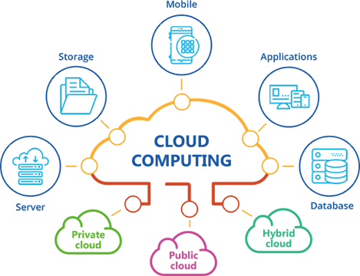

Figure 2.3 Cloud Computing

2.6.1. Cloud Computing

Cloud computing is the on-demand availability of computer system resources, especially data storage and computing power, without direct active management by the user. The term is generally used to describe data centers available to many users over the Internet. Large clouds, predominant today, often have functions distributed over multiple locations from central servers. If the connection to the user is relatively close, it may be designated an edge server.

Clouds may be limited to a single organization (enterprise clouds), or be available to many organizations (public cloud). Cloud computing relies on sharing of resources to achieve coherence and economies of scale.

Advocates of public and hybrid clouds note that cloud computing allows companies to avoid or minimize up-front IT infrastructure costs. Proponents also claim that cloud computing allows enterprises to get their applications up and running faster, with improved manageability and less maintenance, and that it enables IT teams to more rapidly adjust resources to meet fluctuating and unpredictable demand. Cloud providers typically use a "pay-as-you-go" model, which can lead to unexpected operating expenses if administrators are not familiarized with cloud-pricing models.

The availability of high-capacity networks, low-cost computers and storage devices as well as the widespread adoption of hardware virtualization, service-oriented architecture and autonomic and utility computing has led to growth in cloud computing. By 2019, Linux was the most widely used operating system, including in Microsoft's offerings and is thus described as dominant. The Cloud Service Provider (CSP) will screen, keep up and gather data about the firewalls, intrusion identification or/and counteractive action frameworks and information stream inside the network.

**2.7. Components**

An electronic component is any basic discrete device or physical entity in an electronic system used to affect electrons or their associated fields. Electronic components are mostly industrial products, available in a singular form and are not to be confused with electrical elements, which are conceptual abstractions representing idealized electronic components.

Electronic components have a number of electrical terminals or leads. These leads connect to other electrical components, often over wire, to create an electronic circuit with a particular function (example: an amplifier, radio receiver, or oscillator).

Basic electronic components may be packaged discretely, as arrays or networks of like components, or integrated inside of packages such as semiconductor integrated circuits, hybrid integrated circuits, or thick film devices. The following list of electronic components focuses on the discrete version of these components, treating such packages as components in their own right.

The project includes the following components:

1. Arduino UNO x 1
2. NodeMCU x 2
3. Fingerprint sensor x 1
4. RGB led x 1
5. LDR x 1
6. PIR motion sensor x 1
7. DHT11 x 1
8. Smoke detector x 1
9. Flame sensor x 1
10. Vibration sensor x 1
11. Led (3V) x 14
12. Jumper wires
13. Bread boards x 5
14. 220Ω resistors
15. 1k resistor x 1
16. Pin switches x 3
17. 18650 Batteries x 6

2.7.1. Arduino UNO

The Arduino Uno is an open-source microcontroller board based on the Microchip ATmega328P microcontroller and developed by Arduino.cc. The board is equipped with sets of digital and analog input/output(I/O) pins that may be interfaced to various expansionboards(shields) and other circuits. The board has 14 Digital pins, 6 Analog pins, and programmable with the Arduino IDE (Integrated Development Environment) via a type B USB cable. It can be powered by the USB cable or by an external 9-volt battery, though it accepts voltages between 7 and 20 volts. It is also similar to the Arduino nano and Leonardo. The hardware reference design is distributed under a Creative common. Attribution Share-Alike 2.5 license and is available on the Arduino website. Layout and production files for some versions of the hardware are also available.

The word "uno" means "one" in Italian and was chosen to mark the initial release of the Arduino Software. The Uno board is the first in a series of USB-based Arduino boards, and it and version 1.0 of the Arduino IDE were the reference versions of Arduino, now evolved to newer releases. The ATmega328 on the board comes preprogrammed with a boot loader that allows uploading new code to it without the use of an external hardware programmer.

While the Uno communicates using the original STK500 protocol, it differs from all preceding boards in that it does not use the FTDI USB-to-serial driver chip. Instead, it uses the Atmega16U2 (Atmega8U2 up to version R2) programmed as a USB-to-serial-converter.

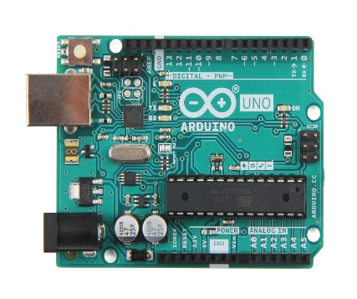

Figure 2.4 Arduino UNO

2.7.2. NodeMCU 0.9

NodeMCU is an open source IoT platform. It includes firmware which runs on the ESP8266 WIFI SOC from Espressif Systems, and hardware which is based on the ESP-12 module. The term "NodeMCU" by default refers to the firmware rather than the development kits. The firmware uses the Lua scripting language. It is based on the eLua project, and built on the Espressif Non-OS SDK for ESP8266. It uses many open-source projects, such as lua-cjson and SPIFFS.

The pins out diagram of NodeMCU is as follows:

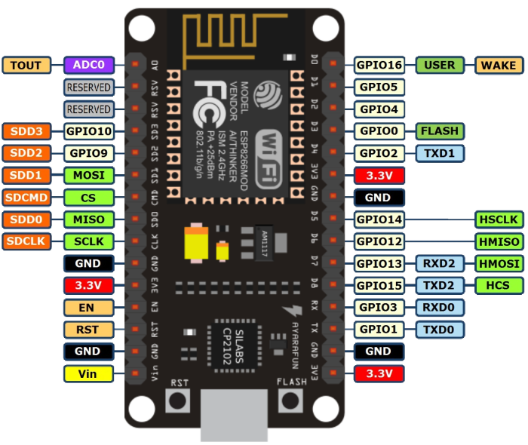

Figure 2.5 NodeMCU 0.9

2.7.3. Fingerprint Sensor (JM-101)

This fingerprint, JM-101, sensor simplifies the process of fingerprint detection, storage, and verification. Inside the sensor is a high-power DSP chip that does all image rendering, calculation, feature finding, and searching.

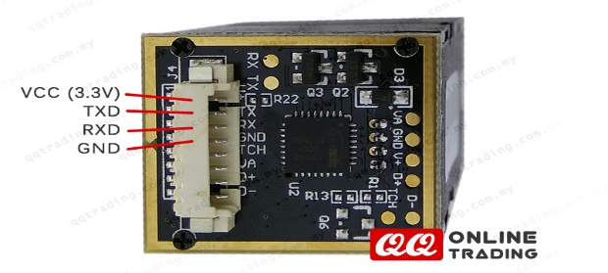

Figure 2.6 Fingerprint sensor (JM-101)

Features:

* Voltage: 3.3V
* Resolution: 500dpi
* Backlight color: Blue
* Interface: TTL Serial
* Peak Current: 60mA
* Fingerprint Read Time: <1.0 Second
* Dimensions: 48 x 21 x 24 mm

2.7.4. RGB LED

Tri-color LEDs contain three different LED emitters in one case. Each emitter is connected to a separate lead so they can be controlled independently. A four-lead arrangement is typical with one common lead (anode or cathode) and an additional lead for each color. Others, however, have only two leads (positive and negative) and have a built-in electronic controller.

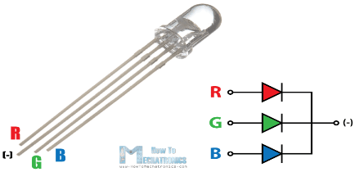

Figure 2.7 RGB LED

RGB LEDs consist of one red, one green, and one blue LED. By independently adjusting each of the three, RGB LEDs are capable of producing a wide [color gamut](https://en.wikipedia.org/wiki/Color_gamut). Unlike dedicated-color LEDs, however, these do not produce pure wavelengths. Modules may not be optimized for smooth color mixing.

2.7.5. LDR (Light Dependence Resistor)

An LDRis a component that has a (variable) resistance that changes with the light intensity that falls upon it. This allows them to be used in light sensing circuits.

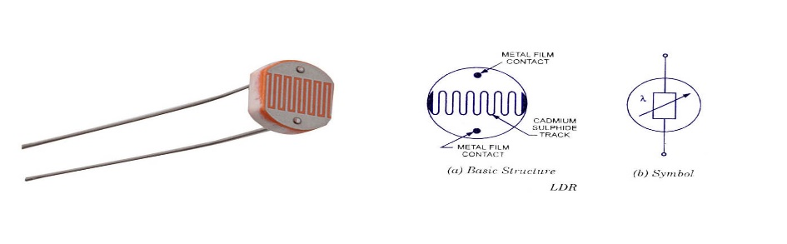

Figure 2.8 LDR (Light Dependence Resistor)

2.7.6. PIR Motion Detector

A motion detector is a device that detects moving objects, particularly people. And when it detects the motion, it gives an output as digital or analog.

Passive Infra-Red sensors can detect movement of objects that radiate IR light (like human bodies). Therefore, using these sensors to detect human movement or occupancy in security systems is very common. Initial setup and calibration of these sensors takes about 10 to 60 seconds.

The HC-SR501’s infrared imaging sensor is an efficient, inexpensive and adjustable module for detecting motion in the environment. The small size and physical design of this module allow you to easily use it in your project.

The output of PIR motion detection sensor can be connected directly to one of the Arduino (or any microcontroller) digital pins. If any motion is detected by the sensor, this pin value will be set to “1”. The two potentiometers on the board allow you to adjust the sensitivity and delay time after detecting a movement. PIR modules have a passive infrared sensor that detects the occupancy and movement from the infrared radiated from human body.

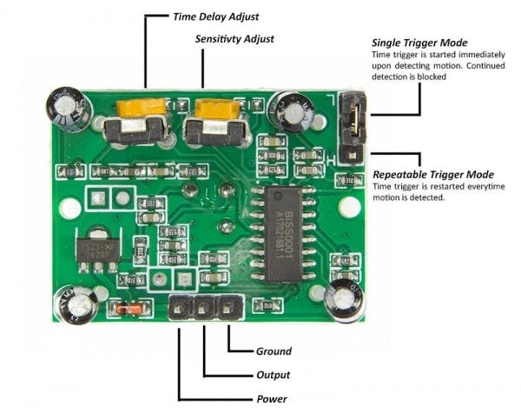 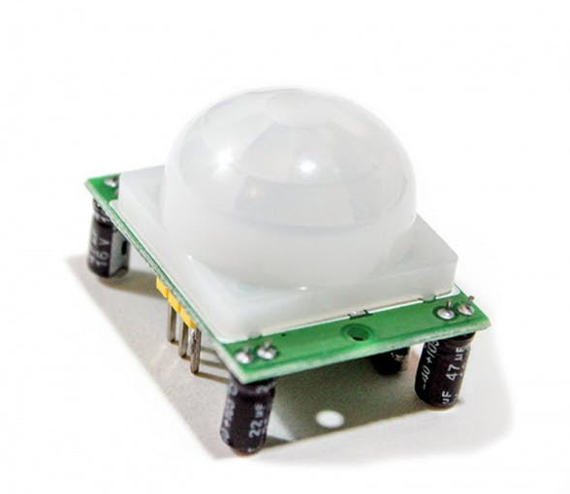

Figure 2.9 PIR Motion Sensor

This module can be used in security systems, smart lighting systems, automation, etc. There are different PIR modules available in the market, but all of them are basically the same. They all have at least a VCC pin, GND pin, and digital output. In some of these modules, there is a ball like a lens on the sensor that improves the viewing angle.

2.7.7. Temperature and Humidity sensor (DHT11)

The DHT11 is a basic, ultralow-cost digital temperature and humidity sensor. It uses a capacitive humidity sensor and a thermistor to measure the surrounding air, and spits out a digital signal on the data pin (no analog input pins needed). It’s fairly simple to use, but requires careful timing to grab data. The only real downside of this sensor can only give new data from it once every 2 seconds, so when using our library, sensor readings can be up to 2 seconds old.

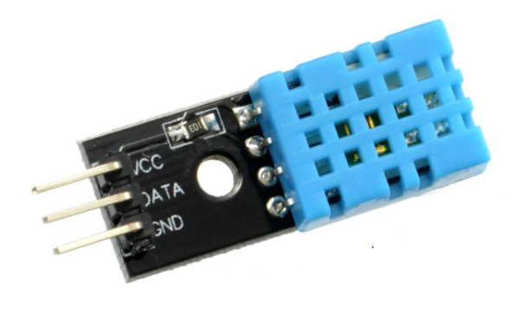

Figure 2.10 Temperature and Humidity Sensor (DHT11)

2.7.8. Smoke Detector (MQ-135)

The MQ-135 Gas sensors are used in air quality control equipment and are suitable for detecting or measuring of NH3, NO2, Alcohol, Benzene, Smoke, CO2. The MQ-135 sensor module comes with a Digital Pin which makes this sensor to operate even without a microcontroller and that comes in handy when you are only trying to detect one particular gas. If you need to measure the gases in PPM the analog pin needs to be used. The analog pin is TTL driven and works on 5V and so can be used with most common microcontrollers.

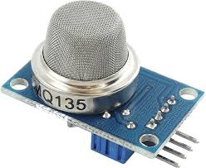 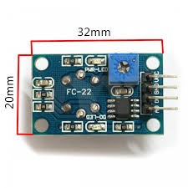

Figure 2.11 Smoke Detector (MQ-135)

2.7.9. Flame Sensor

Flame sensor module has photodiode to detect the light and op-amp to control the sensitivity. It has three pins (plus, minus, digital output) and it needs 5V supply to work properly. It is used to detect fire and provide HIGH signal upon the detection. The following flame sensor is IR based sensor.

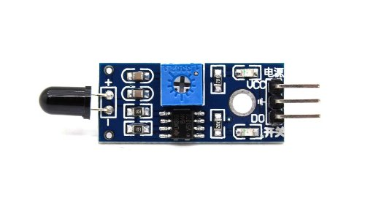

Figure 2.12 Flame Sensor

2.7.10. Vibration Sensor

The vibration sensor is a device that has a vibration sensor element to detect vibration and it also has a PM to adjust the sensitivity of the vibration. It needs 3.3V is enough to work properly well. When no vibration is detected, Vibration sensor output is 0 (low voltage), otherwise its output is 1(high voltage). It also has an LED to indicate when the flame is detected.

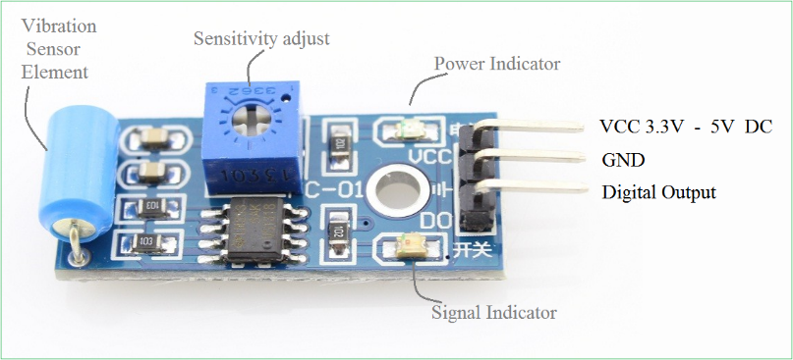

Figure 2.13 Vibration Sensor

2.7.11. LEDs

A light-emitting diode (LED) is a semiconductor light source that emits light when current flows through it. Electrons in the semiconductor recombine with Electron holes, releasing energy in the form of photons. The color of the light (corresponding to the energy of the photons) is determined by the energy required for electrons to cross the band gap of the semiconductor. White light is obtained by using multiple semiconductors or a layer of light-emitting phosphor on the semiconductor device.

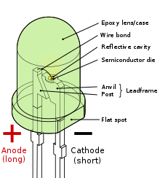

Figure 2.14 LEDs

2.7.12. Jumper Wires

A jump wire is an electrical wire, or group of them in a cable, with a connector or pin at each end, which is normally used to interconnect the components of a breadboard or other prototype or test circuit, internally or with other equipment or components, without soldering.

There are basically three types of jumper wires:

* male to male jumper wires
* male to female jumper wires
* female to female jumper wires

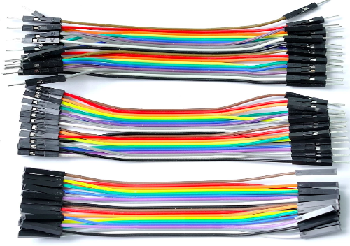

Figure 2.15 Jumper Wires

2.7.13. Bread Board

A breadboard is a construction base for prototyping of electronics. Originally the word referred to a literal bread board, a polished piece of wood used for slicing bread. In the 1970s the solderless breadboard became available and nowadays the term "breadboard" is commonly used to refer to these. Because the solderless breadboard does not require [soldering](https://en.wikipedia.org/wiki/Soldering), it is reusable. This makes it easy to use for creating temporary prototypes and experimenting with circuit design. For this reason, solderless breadboards are also popular with students and in technological education.

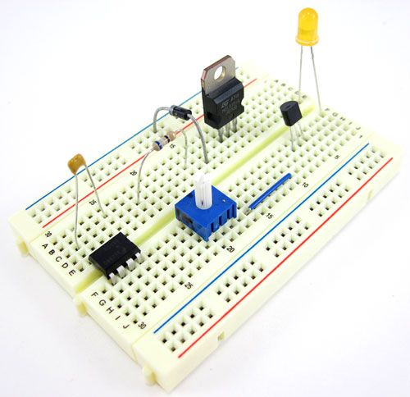

Figure 2.16 Bread Board

2.7.14. Resistors

A resistor is a passive two-terminal electrical component that implements electrical resistance as a circuit element. In electronic circuits, resistors are used to reduce current flow, adjust signal levels, to divide voltages, bias active elements, and terminate transmission lines, among other uses.

Notation

Two typical Schematic Diagram symbols of resistors are as follows:



Figure 2.17 Symbols for Resistors

Ohm's law

The behavior of an ideal resistor is dictated by the relationship specified by Ohm's law:

V = I x R

Ohm's law states that the voltage (V) across a resistor is proportional to the current (I), where the constant of proportionality is the resistance (R). Resistors are measured in Ohm (Ω). Resister can be classified with colors.

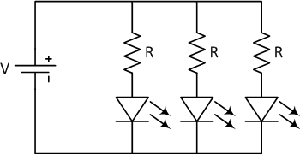

Figure 2.18 Resistors with LEDs

2.7.15. Switches

A switch is a component which controls the open-ness or closed-ness of an electric circuit. They allow control over current flow in a circuit (without having to actually get in there and manually cut or splice the wires). Switches are critical components in any circuit which requires user interaction or control.

A switch can only exist in one of two states: open or closed. In the off state, a switch looks like an open gap in the circuit. This, in effect, looks like an open circuit, preventing current from flowing.

In the on state, a switch acts just like a piece of perfectly-conducting wire. A short. This closes the circuit, turning the system "on" and allowing current to flow unimpeded through the rest of the system.

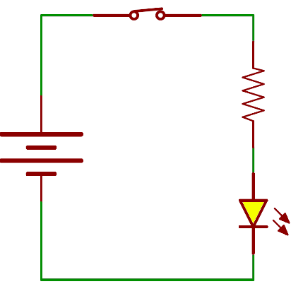 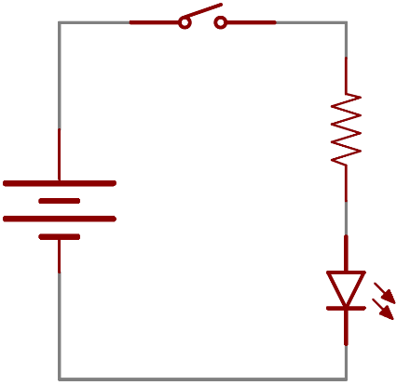 Figure 2.19 Open Switch Figure 2.20 Close Switch

There are tons and tons of switches out there: toggle, rotary, DIP, push-button, rocker, membrane, the list just goes on and on. Each of those switch types has a set of unique characteristics to differentiate it from others.

Characteristics like what action flips the switch, or how many circuits the switch can control. A very simple switch which has 3 Pins is a good example of switch.

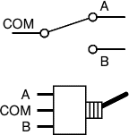

Figure 2.21 Three Pin Switch

2.7.16. 18650 Battery

18650 cells are usually rated at 3.6, 3.7, and sometimes 3.65 volts and 2200mAh-2600mAh. These ratings are all essentially the same. It is the average voltage during a complete discharge. The complete voltage range for most 18650s is between 2.5 volts and 4.2 volts. Many people avoid going below 3 volts. Going above or below this range when charging or discharging can result in heat generation, smoke, fire, or explosion.

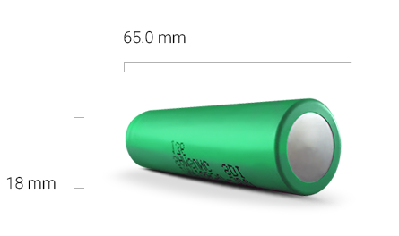

Figure 2.22 18650 Battery

**2.8. Power Supply**

In electronics, a voltage divider (also known as a potential divider) is a passive linear circuit that produces an output voltage (Vout) that is a fraction of its input voltage (Vin). Voltage division is the result of distributing the input voltage among the components of the divider. A simple example of a voltage divider is two resistors connected in series, with the input voltage applied across the resistor pair and the output voltage emerging from the connection between them.

Resistor voltage dividers are commonly used to create reference voltages, or to reduce the magnitude of a voltage so it can be measured, and may also be used as signal attenuators at low frequencies.

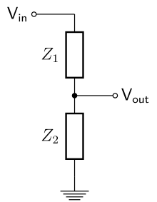

Figure 2.23 Simple Voltage Divider

There are also voltage divider modules in low cost, it needs 12V power supply and gives 3.3V and 5V as output. It has two sinks for the heat, some capacitors and some electromagnetic coil to prevent the current from passing between the wire turns.

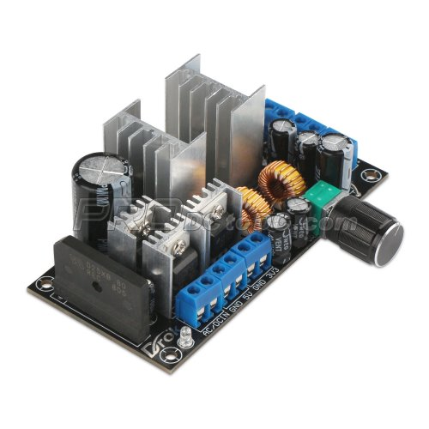

Figure 2.24 Example of Voltage Divider Module

Simple Diagram of a Voltage Divider Module

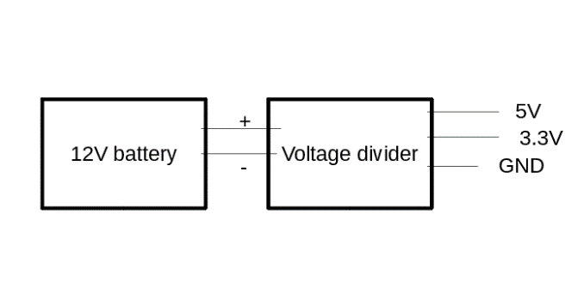

Figure 2.25 Voltage Divider Circuit